**1. Title:** Access the chatbot`s page

**Description:** The user should see Chad welcome message.

Precondition: The user must be already in conversation with the Chatbot.

**Test Steps:**

1. Access the page
2. Wait for his welcome / write him an „hi” message

**Expected Result:** He should start the conversation. If it does not, he should be able to respond to the user message.

**Conclusion:** If Chad start the conversations, he will give a nice response. If the user start the conversation, he will give the same response twice. He will appear as typing.

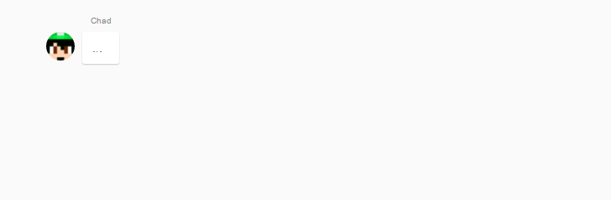

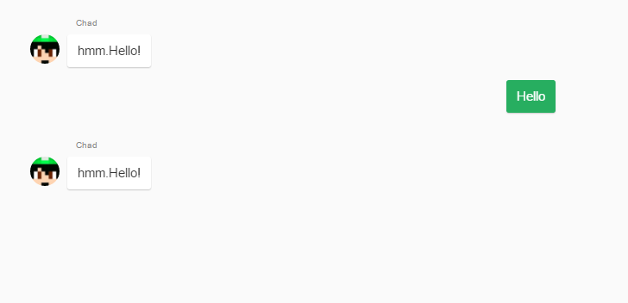

**2. Title:** Ask him simple questions about him.

**Description:** An user should be able to ask him simple questions

Precondition: The user must be already in conversation with the Chatbot.

**Test Steps:**

1. ask him a question and wait for his response
2. ask him another question, meanwhile

**Expected Result:** He should give the answer fast.

**Conclusion:** He process information very slow and even after 3-4 minutes he didn’t answer. He will appear as typing to both questions.

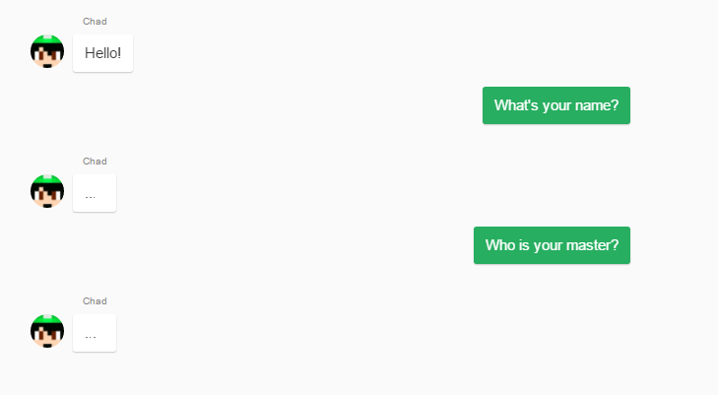

**3. Title:** Ask him something.

**Description:** An user should be able to ask him simple questions

Precondition: The user must be already in conversation with the Chatbot.

**Test Steps:**

1. ask him a question and wait for his response

**Expected Result:** He should give the answer fast.

**Conclusion:** He process information very slow and even after 3-4 minutes he didn’t answer. He will appear as typing.

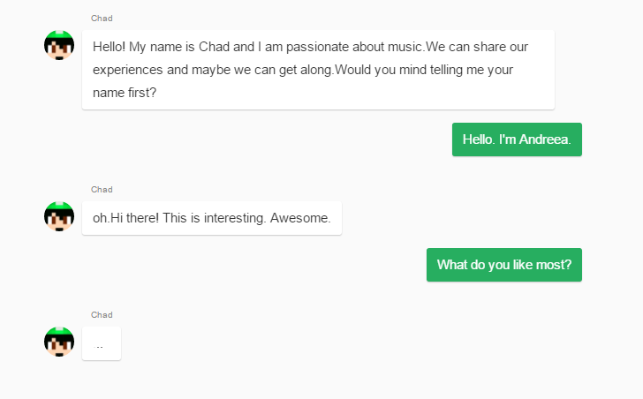

**4. Title:** A single character input

**Description:** An user typing a random character and watching Chad’s reaction.

Precondition: The user must be already in conversation with the Chatbot.

**Test Steps:**

1. send a random character

**Expected Result:** He should ask why did the user send him a random character or to say something about it.

**Conclusion:** He just give unrelated responses.

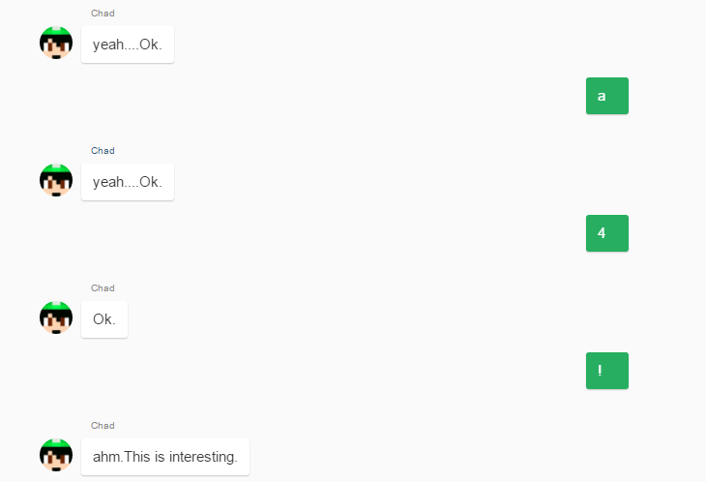

**5. Title:** Ask about something in the knowledge base

**Description:** He should recognize the singer and tell something about him.

Precondition: The user must be already in conversation with the Chatbot.

**Test Steps:**

1. Ask a question about a singer

**Expected Result:** He should give some information about the subject.

**Conclusion:** It doesn’t work. The program will give an warning that he can’t found information about the input.

